TITLE OF BOOK CHAPTER (TNR, Bold 14pt centered)

Author, A¹, Author, B², and Author, C³ (TNR 12pt centered)

¹Institution 1(TNR 12pt centered)
²Institution 2 (TNR 12pt centered)
³Institution 3 (TNR 12pt centered)
E-mail (corresponding author)

ABSTRACT (headlines: TNR Bold, 12pt)
The abstract should be prepared on an A4-sized paper with 25 mm margins on all sides and typed with single spacing using size 12 Times New Roman font. The best is to read these instructions and follow the outline of this text.

INTRODUCTION (headlines: TNR Bold, 12pt)
This document presents the instructions needed to prepare the book chapter of ICANA 2022. Authors are requested to submit a three (3) page book chapter.
The book chapter must include the title, author(s) introduction, material and methods, results and discussion, conclusion and references. The manuscript should be prepared on an A4-sized paper with 25 mm margins on all sides and typed with single spacing using size 12 Times New Roman font. All illustrations must be prepared inside of the main text. Selected papers will be published in the book with ISBN number.

MATERIALS AND METHODS (headlines: TNR, Bold, 12pt)

The methodology must be clearly stated and described in sufficient detail or with sufficient references.

RESULTS AND DISCUSSION (headlines: TNR Bold, 12pt)
The findings and arguments of the work should be explicitly described and illustrated. Supporting figures, tables and images of the
All the tables, images and figures should be centered. Figures and images should be numbered and figure headers should be placed under the figure or image; as for the tables, they should also be numbered and the table header should be placed at the top. References (if any) of the tables, figures and images should be presented right under the tables, figures and images in the form of author surname and publication date.

Tables and figures
Tables and figures should appear in one column of a page and be numbered consecutively. Figures and texts may appear on the same page, and a centered caption should appear directly beneath the figure. It is preferable that figures be mounted in portrait style and figure captions are no longer than two lines. On figures showing graphs, both axes must be clearly labeled (including units if applicable).
Tables should be designed to have a uniform style throughout the paper, following the style shown in Table 1. Table captions should be in 10pt “Time News Roman” bold, centered, and the texts in Table should be set in 9pt “Time News Roman” font.

Table 1. Caption heading for a table should be placed at the top of the table and within table width.
(Use “time news roman” font, size 10pt, No spacing after table title)
 | A | B | C | D
A | Aa | Ab | Ac | Ad
B | Ba | Bb | Bc | Bd
C | Ca | Cb | Cc | Cd
D | Da | Db | Dc | Dd
E | Ea | Eb | Ec | Ed

Authors are advised to prepare their figures in either black and white or color. Please prepare the figures in high resolution (300 dpi) for half-tone illustrations or images. Pictures must be sharp enough otherwise they will be rejected. Figures must be originals, computer-generated or drafted, and placed within the text area where they are discussed. Figure 1 shows one example. Figure captions should be in 10pt “Time News Roman” font, bold, centered. When applicable, the texts in graphs, illustrations or images should be set in 8pt “Time News Roman” font.
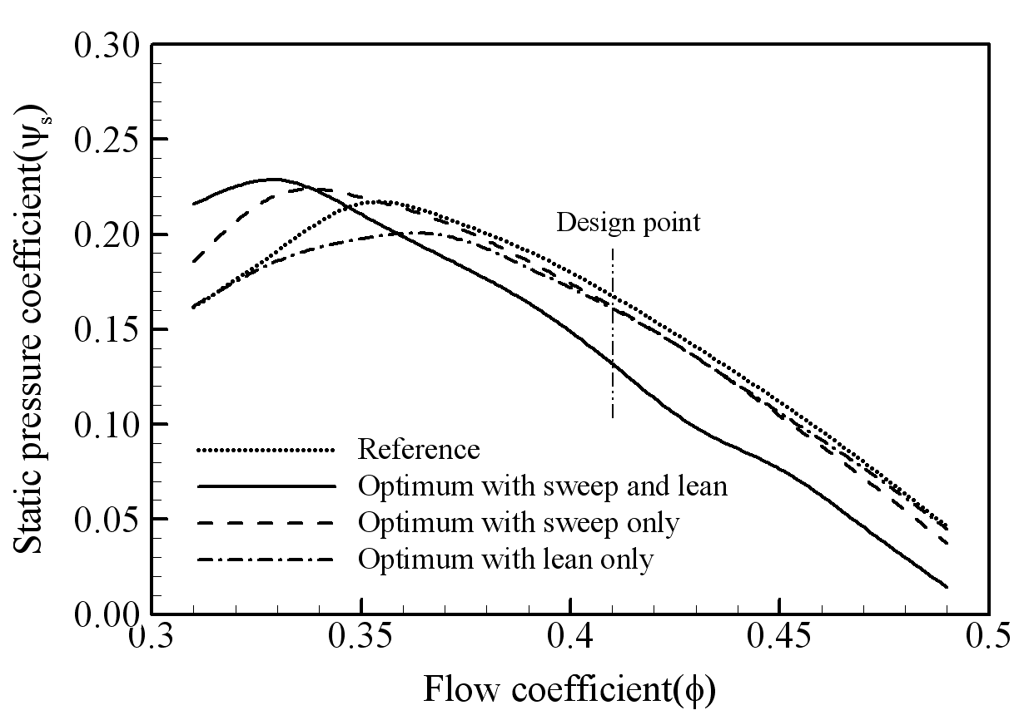
Figure 1. The caption heading for a figure should be placed below the figure and within figure/illustration width. (Use “Time News Roman” font, size 10pt, no spacing between title and figure)

CONCLUSION (headlines: TNR Bold, 12pt)
Conclusions should include (1) the principles and generalisations inferred from the results, (2) any exceptions to, or problems with these principles and generalisations, (3) theoretical and/or practical implications of the work, and (5) conclusions drawn and recommendations.

ACKNOWLEDGMENT (headlines: TNR Bold, 12pt)
The authors may write acknowledgment.

REFERENCES (headlines: TNR Bold, 12pt)
References should be listed arranged in alphabetical order beginning with the author’s names and initials, followed by the year of publication, title of periodical, volume and page. Example:

Parlange, J.Y., R. Haverkamp and J. Touma. 1985. Infiltration under ponded condition: 1. Optimal analytical solution and comparison with experimental observation. Soil Sci., 139: 305-311.

In the text, references should be cited with the name of the author(s) with the year of publication in parenthesis, e.g., Philip (1957), Taylor and Baker (1986), Smith et al. (1987).

